**City University of Hong Kong**

CS3343 Software Engineering Practice

Project Plan

# Project Title: CityU Study Room Scheduler

|  |  |
| --- | --- |
| **Name** | **Student Number** |
| Nurdaulet TAUMERGENOV | 56679550 |
| Anton SHATOKHIN | 56865310 |
| Dilnaz AUSHAKHIMOVA | 57012060 |
| Beket YERMEKOV | 56679630 |
| Nur ALDEKEN | 56679433 |
| Aliya OSPANOVA | 56842241 |
| Alibi ZHENIS | 57065469 |

Table of Contents

Project Title: CityU Study Room Scheduler 1

1. Project Description 3

2. Stakeholders 3

3. Objectives of the Project 4

4. Constraints 4

4.1 Scope 4

4.2 Budget 4

4.3 Time 4

5. Software Development Methodology 5

Test-driven Approach 5

6. Project Team Organization 6

6

Role description: 6

7. Tools 7

8. Configuration management 8

8.1 Version control 8

8.2 Change Management 8

8.3 Documentation Management 8

8.4 Configuration Auditing and Verification 8

9. Work breakdown structure 8

10. Agile project management 9

Task Board 10

Gantt Chart 11

# 1. Project Description

The CityU Study Room Scheduler is a software engineering project aimed at developing an application to efficiently manage and schedule study rooms at City University (CityU). The purpose of this project is to provide an easy-to-use platform that enables students to reserve study rooms, ensuring a fair and organized allocation of these facilities.

The CityU Study Room Scheduler project will follow the software development life cycle, including requirements gathering, system design, implementation, testing, and deployment. It will leverage modern technologies and best practices for a user-friendly and responsive interface.

The project duration is estimated to be 13 weeks and the project team will consist of software developers, testers, a project manager, and stakeholders from CityU's student community. Regular communication and collaboration will be maintained throughout the project to ensure that the final product meets the needs and expectations of the users.

# 2. Stakeholders

|  |  |  |
| --- | --- | --- |
| **Position** | **Internal/External** | **Description** |
| Project Manager | Internal | The project manager oversees the entire project, including planning, organizing, and coordinating the development team. They are responsible for ensuring that the project stays on track, meets deadlines, and satisfies stakeholder requirements. |
| Development Team | Internal | The development team consists of software engineers, designers, and testers who are responsible for implementing and testing the study room scheduler application. They work closely with other stakeholders to gather requirements, design the system, and deliver a functional product. |
| Students | External | Students are the primary users of the study room scheduler. Their role is to utilize the application to reserve study rooms, provide feedback, and make the most efficient use of the available resources. |
| Faculty and Administrative Staff | External | Administrative staff members are responsible for managing the study room scheduler system, maintaining the study room database, generating reports, and handling any technical issues that may arise. They may provide input on requirements, policies, and guidelines related to study room reservations. |

# 3. Objectives of the Project

By implementing the CityU Study Room Scheduler, the developers aim to streamline the study room reservation process, enhance student satisfaction, and optimize the utilization of study room resources.

We ensure:

* Efficient Study Room Allocation: The primary objective of the project is to develop a software application that efficiently allocates study rooms to CityU students,
* Improved User Experience: The project aims to enhance the overall user experience for students by providing a user-friendly and intuitive study room scheduling platform. This includes features such as real-time availability information,
* Administrative Efficiency: The project aims to improve administrative efficiency by automating the study room reservation process. This includes generating reports on room usage, managing reservations, and handling system-related tasks. The system will help streamline administrative workflows and reduce manual effort.
* Fairness and Transparency: The system aims to ensure fairness in study room allocation by implementing rules and policies that prevent monopolization and promote equal access for all students. The project seeks to create a transparent and accountable process that students can rely on for reserving study rooms,
* Optimization of Study Room Resources: By implementing the study room scheduler, the project aims to optimize the utilization of study room resources at CityU. The system will provide insights into room occupancy,
* Integration and Scalability: The study room scheduler project aims to be scalable and adaptable to accommodate future growth and changes within CityU.

# 4. Constraints

## 4.1 Scope

Some requirements from the client are not yet confirmed, so it is expected that the scope will keep changing. The ever-changing requirement may lead to ongoing addition of new functionality in which developers have to pay extra effort on modifying the software design and codes. The extended development period can affect the outcome of the project negatively, and even the worst case – project failure). There may be some requirements, policies, and guidelines related to study room reservations that will hinder the project development process.

## 4.2 Budget

The budget for a project includes personnel costs, infrastructure costs, software licenses, and any other expenses associated with the project. We can consider the personnel costs as a significant component of the budget. This includes the salaries or hourly rates of the team members involved in the project.

## 4.3 Time

The time constraint for the CityU Study Room Scheduler project is defined as a duration of 13 weeks. This means that the project must be completed within this timeframe, including all phases of development, testing, and deployment. The 13-week time constraint poses a challenge in ensuring that all project tasks and deliverables are completed within the allocated timeframe. It requires careful planning, effective project management, and efficient utilization of resources to meet the project objectives and deadlines.

# 5. Software Development Methodology

## Test-driven Approach

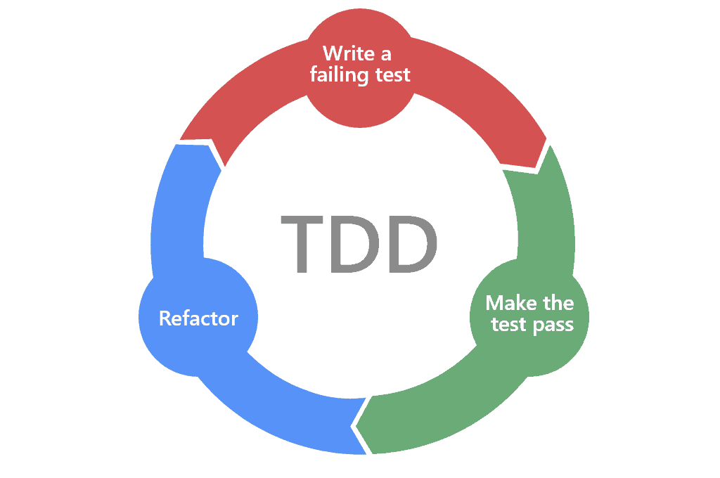

A test-driven approach, also known as Test-Driven Development (TDD), is a software development methodology that emphasizes writing tests before writing the actual code. In this approach, the development process is driven by the creation of automated tests, which guide the design and implementation of the software.

The test-driven approach offers several benefits such as enhanced code quality, rapid feedback, improved design, and increased collaboration.

# 6. Project Team Organization

Project Manager

Testing Team Lead

Developers Team Lead

Program Developer

## 

Program Tester

Program Tester

Program Developer

|  |  |
| --- | --- |
| Name | Role |
| Dilnaz AUSHAKHIMOVA | Project Manager |
| Nur ALDEKEN | Developers Team Lead |
| Nurdaulet TAUMERGENOV | Testing team Lead |
| Aliya OSPANOVA | Program Developer |
| Anton SHATOKHIN | Program Developer |
| Beket YERMEKOV | Program Tester |
| Alibi ZHENIS | Program Tester |

## Role description:

* Project Manager: The project manager is responsible for overseeing the entire project. They plan, organize, and coordinate activities, set project goals, manage resources, communicate with stakeholders, and ensure that the project is delivered on time and within budget.
* Developers Team Lead: The developers team lead is responsible for leading a team of developers. They assign tasks, provide guidance and support, facilitate collaboration, and ensure that the development work is progressing smoothly. They coordinate with other teams, communicate project requirements, and ensure that the team follows coding standards and best practices.
* Testing Team Lead: The testing team lead is responsible for leading a team of testers. They plan and execute testing activities, develop test strategies and plans, create test cases, and oversee the quality assurance process. They coordinate with the development team to understand project requirements, identify, and report bugs, and ensure that the software meets the specified quality standards.
* Program Developer: The program developer is responsible for writing code and developing software applications. They analyse requirements, design software solutions, write and test code, and collaborate with the team to ensure the successful implementation of the software.
* Program Tester: The program tester is responsible for testing software applications to identify defects, bugs, and usability issues. They design and execute test cases, report, and track bugs, and ensure that the software meets the specified quality standards.

# 7. Tools

1. Development Tools
   1. Eclipse IDE 2023-06 (4.28.0)
2. Development Platform
   1. Windows 10 with JDK 21.0.1
   2. Linux
3. Test Cases
   1. Junit 5
4. Coverage Checking
   1. EclEmma 3.1.4
5. Testing Platform (including operating systems and web browsers)
   1. Windows 10
   2. macOS 10.15 (Catalina)
   3. Ubuntu 15.04 + Chrome / Firefox
6. Documentation
   1. **Visual Paradigm 17.0** for use case diagrams, class diagrams and sequence diagrams
   2. **Javadoc** for generating Java manual
   3. **Github** for recording bugs
   4. **Microsoft Word** for report
7. Project Management
   1. **Teambition** and **TeamGantt** for scheduling
   2. **GitHub** for collaboration
   3. **Google Drive** for general file sharing
   4. **Google Doc** for collaborative writing
8. Presentation
   1. Microsoft PowerPoint
   2. GoogleDoc

# 8. Configuration management

## 8.1 Version control

We use a version control system, such as GitHub, to manage the source code of the study room scheduler software. This would involve creating repositories, branching strategies, and ensuring proper versioning and labelling of code changes.

## 8.2 Change Management

Defining a change management process to handle requests for changes to the study room scheduler software. This would include documenting change requests, evaluating their impact, obtaining approvals, and implementing approved changes while maintaining proper version control. GitHub and Buggzilla are used.

## 8.3 Documentation Management

We use systems such as GoogleDoc and GoogleDrive to manage project documentation, including requirements documents, design specifications, user manuals, and any other relevant documentation. This may involve using a document management tool or a shared repository to ensure version control, accessibility, and traceability of documentation.

## 8.4 Configuration Auditing and Verification

Periodically conducting audits or inspections to verify that the deployed configurations align with the approved versions and meet the defined requirements. This helps ensure that the study room scheduler software remains in a known and controlled state. Zoom is used for executing meetings.

# 9. Work breakdown structure

For this project we combined top-down, analogy post-it on a wall method in one to breakdown the work structure. We did the general brainstorming first, then combined the tasks according to their similarity, them a followed a classis project delivery approach. Then we used Gantt Chart to visualize the tasks and keep track of the progress better.

1. Project Management
   1. Topic Selection
   2. Topic Discussion
2. Requirements Gathering
3. Analysis and Design
4. Software Development
   1. Phase 1
      1. TimeSlot Class Creation
      2. StudyRoom Class Creation
      3. ListRooms Class Creation
   2. Phase 2
      1. Event Class Creation
      2. EventLog Class Creation
   3. Phase 3
      1. GUI Development
   4. Phase 4
      1. Menu Development
      2. GUI Development
5. Testing
   1. Testing Approach Selection
   2. Unit Testing
   3. Integration Testing
   4. System Testing
   5. User Acceptance Testing
6. Documentation
   1. Use Case Diagram
   2. Class Diagram
   3. Sequence Diagram
   4. Bug Report
   5. Final Report

# 10. Agile project management

We used agile project management methodology, because software teams that embrace agile project management methodologies increase their development speed, expand collaboration, and foster the ability to better respond to market trends. Agile project management is an iterative approach to managing software development projects that focuses on continuous releases and incorporating customer feedback with every iteration.

To look over the progress the team makes, we used a Gantt chart to visualize the task flow and priority. The team collaborated using Monday.com platform which is easy to use and understand. With the help of the chart, teammates could monitor the progress of others and collaborate on a lot of problems.

The tasks are divided into typical Software Development Phases. For each cycle we identified the milestone to track the progress more efficiently. The tasks on the Gantt chart are coloured according to the task group and milestones are illustrated as rhombus.

## Task Board

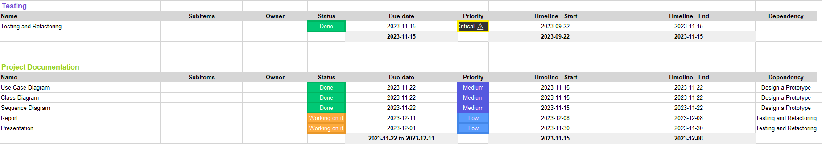

## Gantt Chart

